PACK 3250 PINEWOOD DERBY RULES AND SPECIFICATIONS

LION CUBS
- For Kindergartners construction is simplified.
- The cars will come pre-cut into wedge shapes and no additional cutting of the body may be made. It is allowed to sand the surface and edges to remove splinters and rough spots but no major sanding to reduce the size and shape of the car is allowed. All wheel/axle race rules specified below must also be followed. Accessories and weights MAY be added to the car so long as the car still conforms to size and weight limits as outlined later.
- Only the wheels and axles in the kit may be used unless they are damaged (in which case see the Cubmaster for replacements).

Tiger, Wolf, Bear, Webelos and Open Division Participants
- Older Cub Scouts will receive a pine block that may be cut into whatever shape/design the Scout wants (assuming it is physically possible and you have the tools to do it). All wheel/axle race rules specified below must also be followed. Accessories and weights may be added to the car so long as the car still conforms to size and weight limits as outlined later.
- Only the wheels and axles in the kit may be used unless they are damaged (in which case see the Cubmaster for replacements).
- For additional information see the “Building a Car for Lions” page.

Race Format and Expectations
- The Pinewood Derby is intended to be a fun event for the scouts where he or she will learn a little about design, woodworking, kit assembly and good sportsmanship and end up with a car that the scout can take pride in knowing they truly built it. The scouts should be performing most of the design, construction, decorating, painting, sanding, etc. as safety permits. Obviously, it is dangerous for kids to use power tools, especially powered saws so leave that part to the adults.

- Scouts will compete against other scouts of their rank (Lion, Tiger, Wolf, Bear, Webelos I, Webelos II). Awards will be given to the top 3 in each rank. The Rank winners will then compete against the other rank winners for Pack honors. Top three Pack racers will additionally receive awards.

- Any parents, siblings, other family members or even scouts may purchase additional cars to race in the Open division.

- Race format is based on a lowest time scoring system. Computer software is used to track the time for each car in each heat. All cars will run the same number of races and once in each lane with the lowest average time used to establish winners.

Good Luck bust most importantly, have a great time!

Building a Car – The Basics
Step 1: Know the rules
These rules can also be downloaded from www.pack3250.com.
Step 2: Design the Car’s Body
Lion cars are pre-cut into wedges so design for them is limited to decoration and weight. Decide what you want from your car. Do you want to build a car for Speed? Do you want to build a car for Theme? Do you want it to look like something other than a car? Come up with a design that will maximize your enjoyment of the process.
Check the axle grooves to ensure each one is a perfect 90-degree angle to the car body. A car with untrue axles will steer to one side causing it to rub on the track, slowing it down. You can check the grooves with a t-square, protractor or even a piece of paper. To prevent wood splitting, drill a pilot hole into each axle groove before attempting to attach the axles (nails). Use a No. 34 drill bit which is just under the size of the axles and drill out the grooves. You will need to make sure you don’t drill the axles “out of square”.

Step 3: Cleaning the Axles
The nail that serves as the axle and comes in the kit must be used in the construction of your car. These axles provide no bearing surface so there is friction between them and the plastic wheels. Since friction reduces speed you may want to minimize the contact surface ad make the surfaces smooth and lubricated. The following are some suggestions.
Axle Burr Removal: The heads of the nails tend to have molding, or casting, marks in two places where the head attaches to the shaft. You can remove this with a file, just be careful not to scratch or gouge the nail (this will add friction). It is recommended to secure the axle in a drill press or an electric drill that is secured into a secure position, start the drill and gently remove the burrs by touching the file to the nail.
Wheel Burr Removal: The plastic wheels typically have rough ridges along the rims. You can gently sand these off as long as the wheel is not greatly modified (see additional wheel specifications later).

Step 4: Painting and Finishing
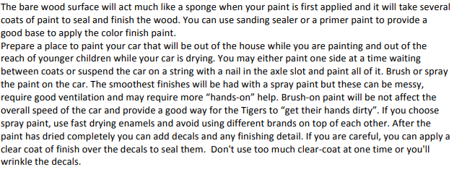

Building a Car – Getting more Complicated
